What would you fast for?
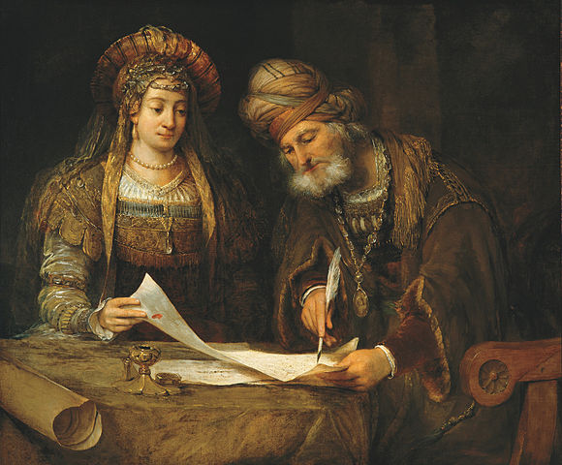
One of the messages of Purim is that we can and should take action in some form when we are aware of injustice in our society. Esther and Mordechai devise a plan to save the Jews from Haman’s evil scheme.
Esther and Mordechai, Aert de Gelder
Esther said to Mordechai:
"Go and gather all the Jews who are in Shushan and fast for my sake. My maids and I shall also fast in the same way. Then I shall go to the king..."
"לֵךְ כנוֹס אֶת כָל הַיּהוּדִּים הַנמצאִּים, בשוּשָן, וצוּמוּ עָלַי. גַם אֲניִּ ונעֲַרתַֹי אָצוּם כֵן, וּבכֵן אָבוֹא אֶל הַמֶלֶךְ אֲשֶר לֹא כַדָת, וכַאֲשֶר אָבַדתִּי אָבָדתִּי"
Still today, unfortunately, we are surrounded by injustice and social issues that need changing. In this activity the students will share what is the cause they would fast for/ take action to repair so that we can live in a better society.
The Activity:
Use LINO or Padlet to create a collaborative workspace for both classes:
Just as the Jews found Mordechai's request to fast worthwhile, we ask you to share with us causes or events in or outside your community that you would consider worthy fasting/taking action about
1. Choose a color of your note - blue for Israelis / red for your twinned class (or any other color you would prefer to assign to the class).
2. Write a note with your idea and post it. Review the other student’s posts and ideas.
3. Having read your friends notes, share your thoughts about them in the Comments on the right. Are the ideas of the friends in your twinned school different or similar to those in your school? If so, in what way?
Please add a response to two notes (at least) - one written by a friend from your own class and one by a friend from the twinned class.
4. Discuss the similarities and differences between your choices and the choices of the twin class.

